Data Structures Linked

<https://youtu.be/FjzXWVd4GhY>

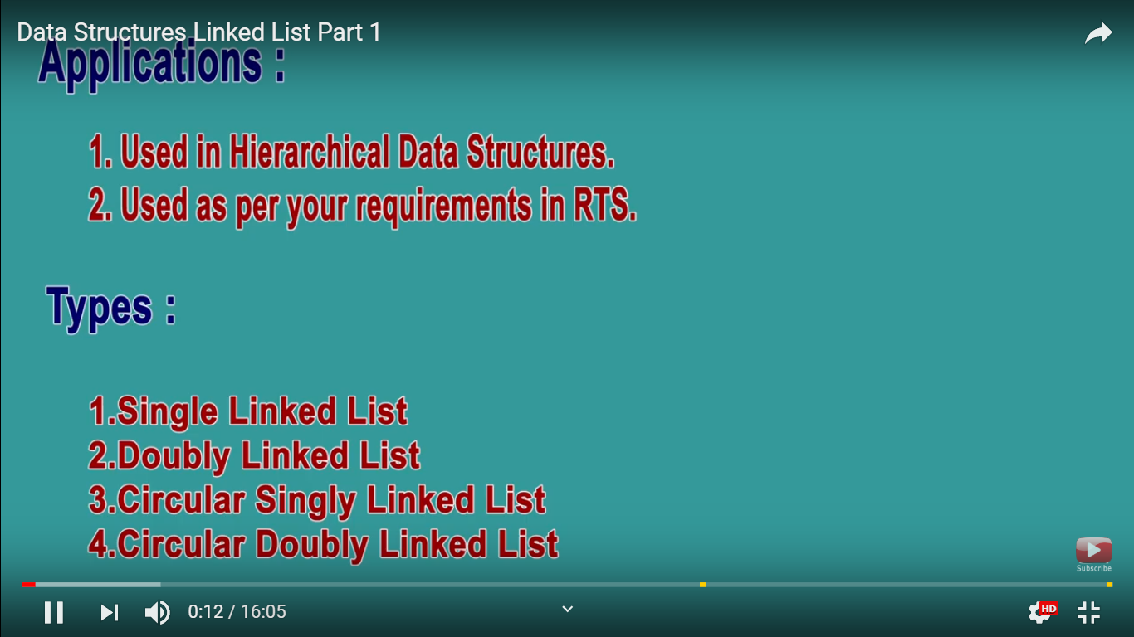

Hierarchical Data namely Tree and Graph.

Tree is combination of linkedlist data structure